**RICHFIELD**

**FACULTY OF INFORMATION TECHNOLOGY**

**PROGRAMMING 512**

**2ND SEMESTER ASSIGNMENT**

**Name & Surname: _________________________________ ICAS No: ________________________________**

**Qualification: ______________________ Semester: _____ Module Name: __________________________**

**Date Submitted: ___________**

|  |  |  |  |
| --- | --- | --- | --- |
| **ASSESSMENT CRITERIA** | **MARK**  **ALLOCATION** | **EXAMINER MARKS** | **MODERATOR MARKS** |
| **MARKS FOR CONTENT** | | |  |
| **QUESTION ONE** | **100** |  |  |
|  |  |  |  |
|  |  |  |  |
| **TOTAL MARKS** | **100** |  |  |
| **MARKS FOR TECHNICAL ASPECTS** | | |  |
| **1. TABLE OF CONTENTS** |  |  |  |
| **2. LAYOUT AND SPELLING** |  |  |  |
| **3. REFERENCE** |  |  |  |
| **TOTAL MARKS** | **100** |  |  |
| **TOTAL MARKS FOR ASSIGNMENT** | **100** |  |  |
| **Examiner’s Comments:** | | |  |
|  | | |  |
|  | | |  |
| **Moderator’s Comments:** | | |  |
|  | | |  |
|  | | |  |
| **Signature of Examiner: Signature of Moderator:** | | |  |

**QUESTIONS [100 MARKS]**

**QUESTION ONE [100 MARKS]**

Objectives: Develop an Institution management system (based on VB.NET platform) linked with Microsoft Access Database as infrastructural support. The primary purpose of this application is to automate students, modules, staff’s information and other data resources.

**The system Functionality**

* 1. Create the following database for the following list and add functions to each one of

them **(40)**

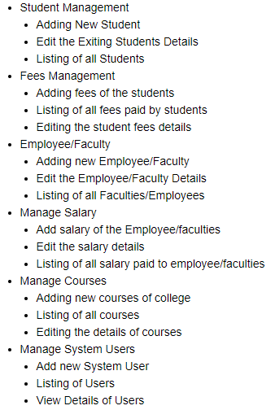

* 1. Create login system for admin and users **(20)**

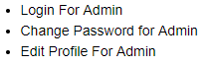

* 1. Connect the database to the project **(20)**
  2. Error Handling exceptions should be included where appropriate **(20)**

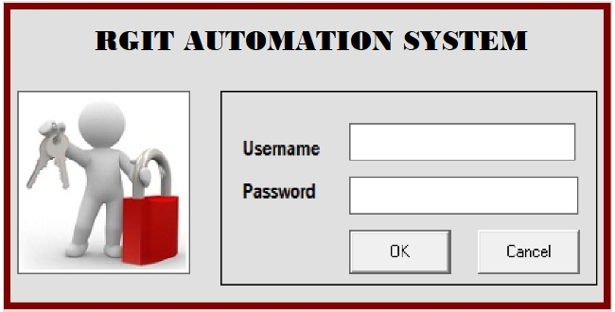

**Figure 1.1: Login**

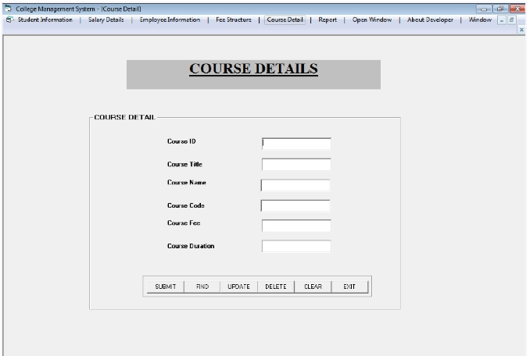

**Figure 1.2: Course login**

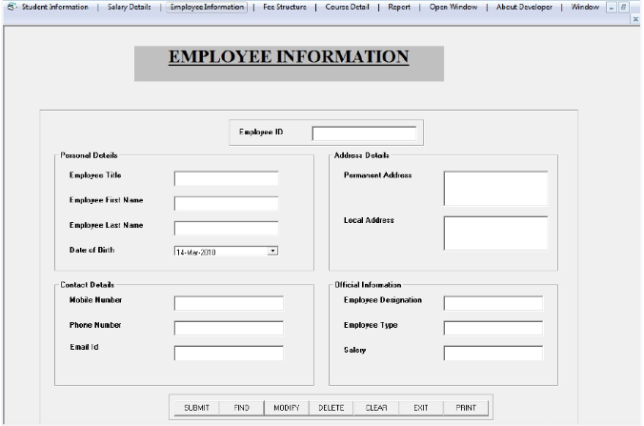

**Figure 1.3: Employee Information**

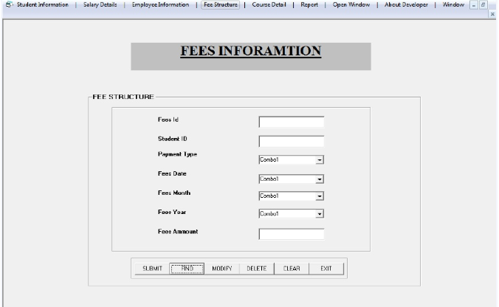

**Figure 1.4: Fees Information**

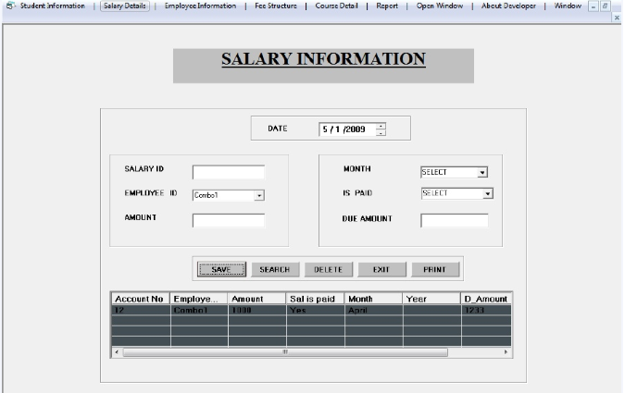

**Figure 1.5: Salary Information**

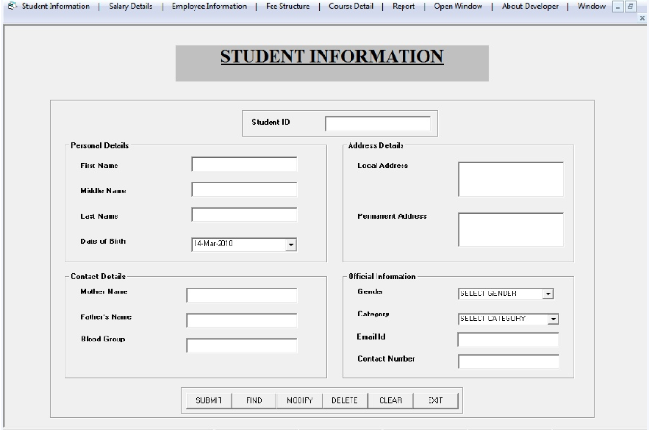

**Figure 1.6: Student Information**

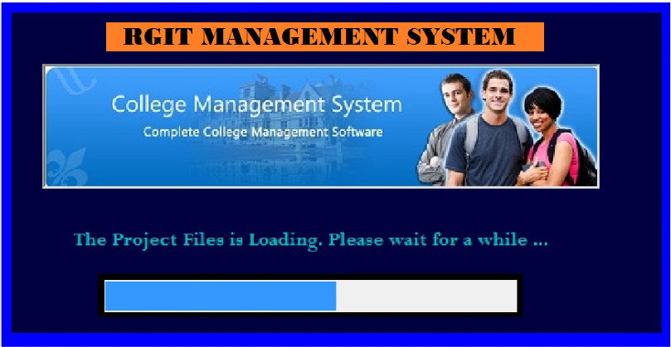

**Figure 1.7: Loading form**

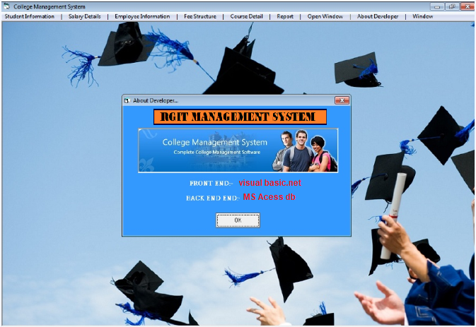

**Figure 1.8: About the Developer**

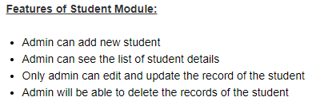

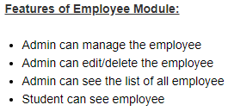

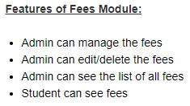

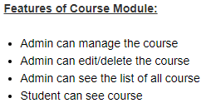

*Implications*: The RGI Linked Database will be used in combination with medical record audits to provide a comprehensive evaluation of health system performance.

*Security measures*

* Put identification, authentication and authorization measures in place.
* Ensure that only authorized personnel can have access to the system.
* Be mindful of how student data is secured and implement a good accuracy.